Open Veterinary Journal
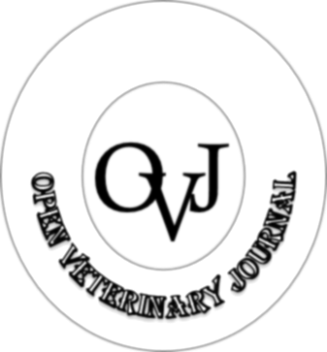
Manuscript Submission Form
This form must be signed ONLY by the Corresponding author on behalf of all co-authors. Once done, then please attach it electronically during the online manuscript submission.
The corresponding author must read the below statement of originality and authorship, sign the document as indicated below (The corresponding author should add all co-authors names below).

Manuscript Title: ………………………………………………………………………………………………………………………………………

………………………………………………………………………………………………………………………………………………………………………

Statement of Originality and Authorship
- I approve the submission of the above-mentioned manuscript to the Open Veterinary Journal.
- I agree that the named corresponding author shall be the sole correspondent with the Open Veterinary Journal editorial office on all matters related to this manuscript.
- I attest that the corresponding author and each author mentioned below has made a scientific contribution to the study.
- I confirm that the manuscript has not previously been published.
- I confirm that the manuscript is not submitted or under consideration for publication elsewhere.
- I accept responsibility for the scientific integrity of the work described in this manuscript.
- I will provide an ethical approval for work involving the use of animals.
- This manuscript is original, and that the manuscript contains no fabrications, fraud, or plagiarism.
- This manuscript will be rejected if the AI-generated content was 50% or higher.

Corresponding Author: …………………………………….. Signature: ……………………………………..

Co-Authors Names

Name: …………………………………….. Name: …………………………………….. Name: ……………………………………..

Name: …………………………………….. Name: …………………………………….. Name: ……………………………………..

Name: …………………………………….. Name: …………………………………….. Name: ……………………………………..

Name: …………………………………….. Name: …………………………………….. Name: ……………………………………..

Name: …………………………………….. Name: …………………………………….. Name: ……………………………………..

Date: / /

